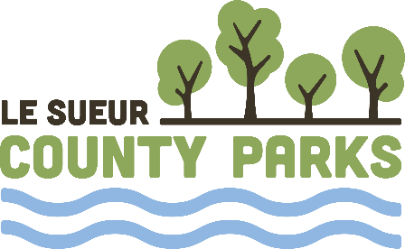
Parks Department
Mailing Address (Le Sueur County Government Center):
88 South Park Avenue, Le Center, MN 56057
Office Location (Le Sueur County Highway Department):
515 South Maple Avenue, Le Center, MN 56057
507-357-8201 www.lesueurcounty.gov

Le Sueur County Parks Board Meeting Agenda
Tuesday, February 17, 5:00PM
Le Sueur County Highway Department Conference Room
- Call to order – 5:00
- Additional agenda items or changes
- Introductions – Parks Board & Guests
- Approve September 16, 2025 Minutes
- Review Parks Board Organizational Structure
- Elect Officers – 1 Year Terms – President, Vice President, Secretary
- Bradshaw Woods – Great River Greening
  - Project Map
- Clear Lake Campground – Funding through Lower Minnesota River East Watershed
- Lake Gorman Park – Dam Replacement
  - Fish Passage Presentation Slide
  - Gorman Dam 90% Plans
- Lake Jefferson Fishing Pier
- 2026 Parks Employees
- 2025 End of Year Parks Projects
- 2025 Financial Review
  - Lake Washington Regional Park & Campground
    - 2025 Revenue & Expenses
    - 2025 Miscellaneous Revenues
  - Clear Lake Campground
    - 2025 Camping Data
  - Richter Woods Park
    - 2025 Barn Rental Report
    - 2025 Revenue / Expense Report
- 2025 Budget
  - Budget - $483,226 Rev / $483,226 Exp
  - Actual - $498,801 Rev / $407,441 Exp.
- 2026 Budget
  - $503,773 Rev / $503,733 Exp
- Future Meetings
  - Tuesday, May 19; Tuesday, September 15
- Other
- Adjourn

