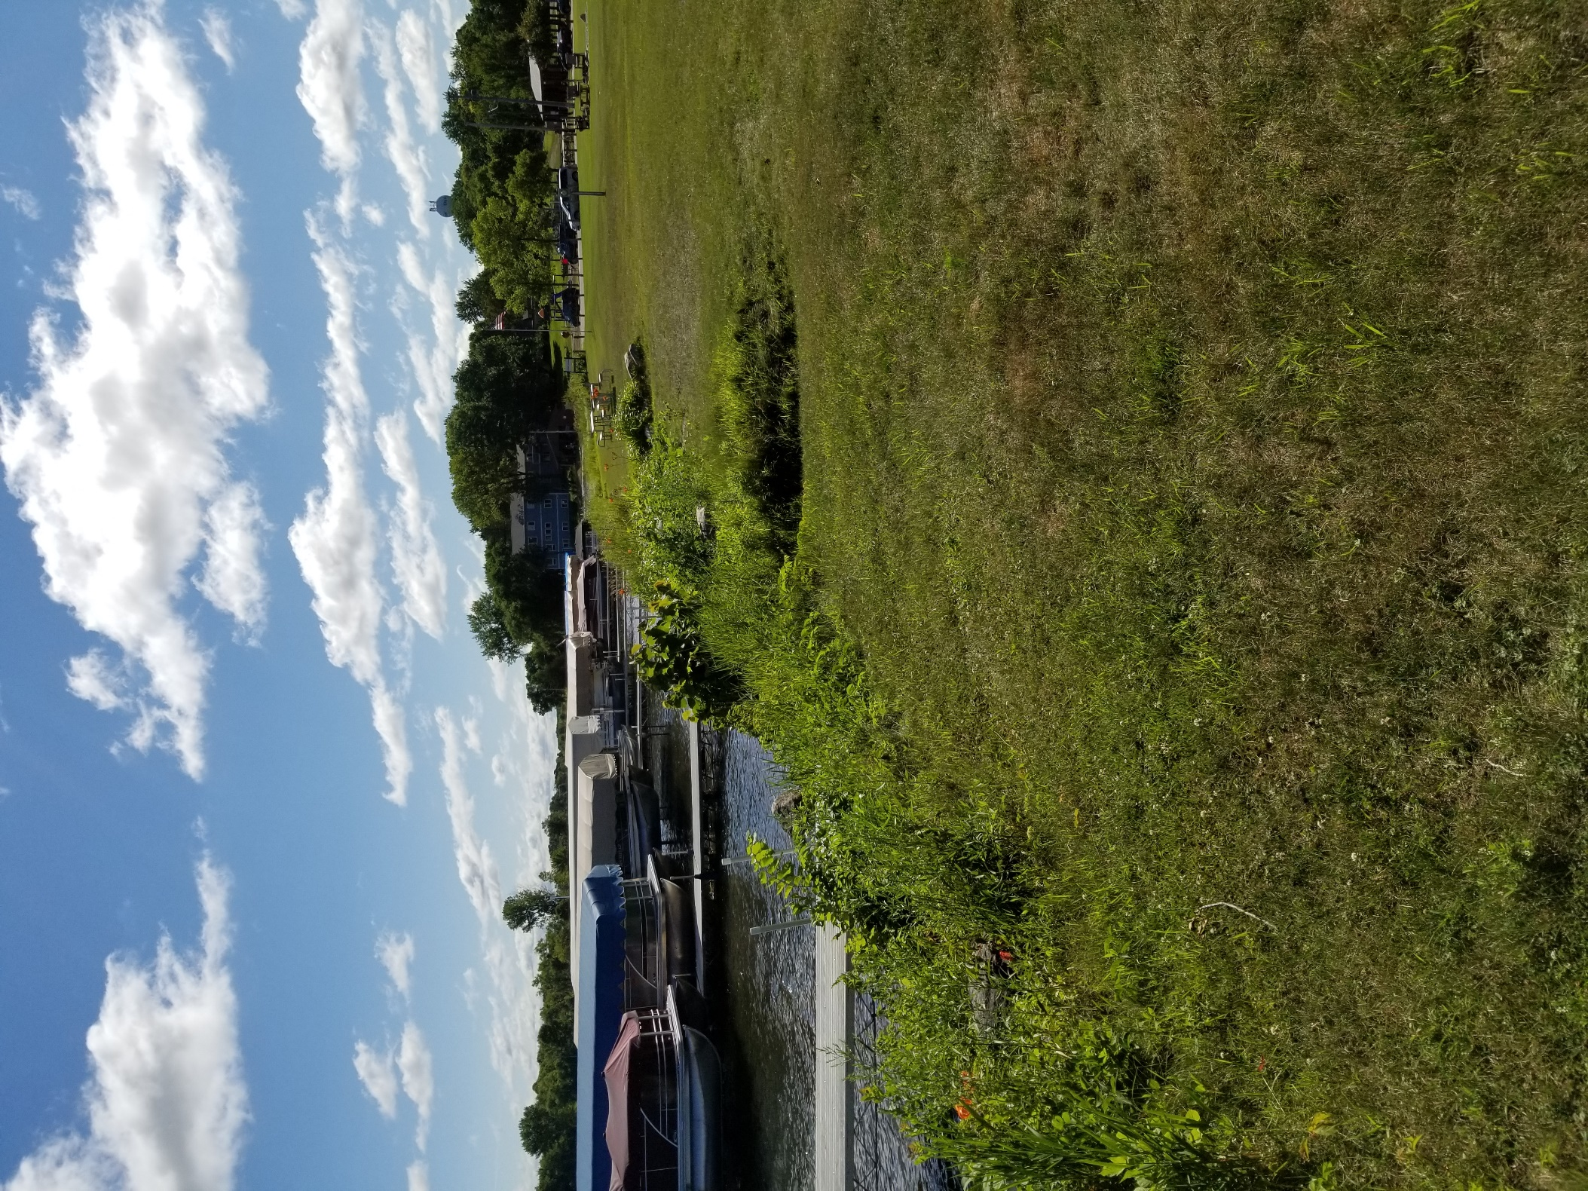
Protect Our Lakes
Clean and Dry your Equipment
Before moving your docks, lifts, rafts, and other associated equipment to a different body of water:
- Remove any AIS or debris that is present.
- Wash/rinse off your equipment.
- Dry your equipment for at least 21 days.

Le Sueur County needs shoreline residents’ help with this program!
- Up to 65 shoreline residents can participate and will be given a free yard sign and AIS sticker.
  - Participants are asked to post their yard sign to encourage others to dry their equipment for 21 days before moving.
- Shoreline residents are given two additional options for further participation.
- Participants want to practice or see a hands-on-demonstration and/or training using tools to clean or wash their equipment.
    - Participants will receive a goodie bag (bait bag, rapala, and bobber).
- Participants intend to move previously-owned equipment either into or away from their lake, but will dry their equipment at least 21 days prior to moving.
    - Participants will receive a free aquaweed stick.

Commitment Form
The Minnesota DNR and Le Sueur County strongly encourages you to clean and dry your docks, lifts, rafts, and other associated equipment for at least 21 days before moving. Not only is it the law, all of these efforts will help reduce the spread of aquatic invasive species in Minnesota.
I, ______________________________, will clean equipment and let it dry for 21 days before moving it.
(sign name here)
Participation Form
Would you like to participate in this program? If so, fill out the information below. By signing this form, you are agreeing to participate with Le Sueur County’s Aquatic Invasive Species Behavior Change program which will help prevent and limit the spread of Aquatic Invasive Species. If at any time, you, the participant, decide to change your level of commitment you are more than welcome to do so, but must notify the Environmental Resources Specialist, Holly Kalbus, as soon as possible.
Your First and Last Name: _______________________________________________________
Your Mailing Address: __________________________________________________________
Your preferred mode of communication (phone or email): ____________________________

Please indicate what level of participation you would like to be involved in (please check one):
☐ I will post a yard sign on my lakeshore property to publicize my commitment for preventing and limiting the spread of AIS, which will encourage my neighbors and community to do the same.
☐ I will post a yard sign on my lakeshore property to publicize my commitment for preventing and limiting the spread of AIS, which will encourage my neighbors and community to do the same. I will also attend at least one of the trainings and/or hands-on-demonstrations that are provided by Le Sueur County.
☐ I will post a yard sign on my lakeshore property to publicize my commitment for preventing and limiting the spread of AIS, which will encourage my neighbors and community to do the same. I will also attend at least one of the trainings and/or hands-on-demonstrations that are provided by Le Sueur County. Lastly, if I buy or sell used equipment (dock, lift, raft, or other associated equipment), I will clean and dry it 21 days before moving to another body of water.
___________________________________________ _______________
Participant Signature Date

